eScience@ANU a new teaching/research group in Australia

Hugh Fisher, Henry Gardner, Rod Harris, Sam Taylor, Pascal Vuylsteker, David Walsh
<firstname.name>@anu.edu.au
Computer Science, Faculty of Engineering and IT,
Australian National University, Canberra ACT 0200, Australia

Abstract
We present a new teaching and research group in Australia working in the eScience area. We propose a definition for that term and explain how we use a Java3D interface to a two-walled, CAVE-like theatre (the “Wedge”) to provide an exiting learning environment. We illustrate our research orientation by short presentations of a set of projects that have already been carried out.
Keywords:
Java3D, CAVE, teaching, CVE (Collaborative Virtual Environment)

Introduction
Virtual Reality (VR), as a trend and a terminology, has its ups and downs.
Although people occasionally prefer to label VR research as Computer Graphics, Simulation, HCI, Virtual Environments, iCinema or other things, the basic question remains the same: How can we use a computer to represent the real world (or totally abstract data) with an interface as natural and as efficient as possible.
The required competency mix of the people working in the area of VR has also remained the same for some time: very good programming and problem solving ability, knowledge of algorithms and computer graphics and experience in HCI, usability and software engineering. It turns out that these competencies are also highly valued by IT industry and it also turns out that students who come from a background of science and engineering are especially keen and able to learn them in a framework which has VR as a central focus.
In this paper, we describe some of the activities of an Australian graduate education program, which takes physics or engineering students, and teaches them IT, programming and software engineering principles using VR as a "pedagogical hook". We will present the context and teaching tools and outline some parts of our pedagogical emphasis. We then describe some examples of our, and our students, work.

eScience
By the term “eScience” we mean the skills involved in the analysis, presentation, and management of data in commerce, industry and research; the use of computer analysis, modelling and data presentation tools; and the use of the World Wide Web and virtual environments for presentation and cooperation in the use of data.
From another point of view we have located eScience at the intersection of science, engineering and IT.
Indications from IT employers are that science and engineering graduates turn out to be excellent IT professionals after a phase of appropriate training, and there are positions in the industry which require the strong analytical skills of these graduates.

Wedge (Figure 1)
The Wedge [1] is a two-walled stereoscopic theatre resembling a mini-CAVE [2]. It was originally built as a “home-brew” alternative to purchasing a commercial system for a cash-strapped university but has also found a place in Australian museums and visitor centres. The original software interface was written in C++ and OpenGL [3]. Several higher level APIs, based on Python and Optimizer/Cosmo3D [3,4], Performer [5] and Avango [6] have been used to build Wedge applications. Today, we are using Java3D as a basis for our new developments.
Like the CAVE, the Wedge enables participants to see each other, the environment and themselves as well as viewing a 3D stereographic scene. It is suitable for collaborative virtual reality even though only one viewer has the correct viewpoint. In fact, where the system has been used in museums and visitor centres, it has been found expedient to fix a viewpoint in a central location and eliminate headtracking. Depending on the nature of the visualisation the experience of being a simple, companion viewer can be quite a thrilling one for members of the general public.
When a lead viewer moves his or her head position, the 3D perspective graphics can rotate relative to the fixed theatre.

Tiwi
To facilitate student access to the Wedge, we have built a new Java3D software toolkit (the Tracked Interactive Wedge Interface - TIWI - developed initially by David Walsh). Even if it has been rumoured that the next release [17] of Java 3D will include a new utility to configure CAVE like system (ConfiguredUniverse [18]), we could not organize our student projects around a simple announcement. So, we have developed a SimpleUniverse like package that allows students to work on any simple PC in their lab and just transfer their code to the Wedge platform to run it without (almost!) any change.

Teaching
Recently, the Australian National University has started a new graduate education program, called eScience [7], which includes the Wedge as a focus for student projects. The program is broadly based and uses Virtual Reality as a “pedagogical hook” to teach students important programming and software engineering principles - as well as computer graphics and human computer interaction.
The eScience program is initially provided by competitive funds from the Australian Government DETYA under the Science Lectureship Initiative, and draws on staff, equipment, laboratory and software at the ANU and at RMIT University in Melbourne.
The Graduate Diploma in IT (eScience) degree was approved at ANU in 2000. The first intake of students started in semester 1 2001. In March, this year, we are beginning a new Masters.

The choice of Java
The choice of Java as a teaching language is not really original [15]. Horstmann and Cornel [16] give us, in their analysis of the “Java White Paper Buzzwords”, a set of good reasons to choose this language in general (Simple, Object Oriented, Distributed, Robust, Secure…). What has really interested us in the context of our teaching goals was the ability to get, at the same time, some strong graphical interface capabilities (Java2D, Java3D), and the networking orientation (JMF, Shared Data Toolkit). The hidden drawback of this rich set of APIs is nevertheless the fact than when using some of then, you may lose the famous “write once, run everywhere” characteristic of Java. Java3D or JMF, for instance are not yet available on MacOSX.

Examples of Projects
In the following sections we present some of the projects on which we have been working recently in order to illustrate the research interests of the group.

Example of a student project: 3D sound sculpturing
The first example is a software system, which has evolved through two student projects (by eScience student Rod Harris and Engineering student Emma Francis) using Java3D and TIWI. The object of the system is to interactively design a 3D spatial soundscape. The composer is able to describe paths in space and time and to place sounds on these paths. The soundscape can be played back and edited either within the virtual environment itself or, remotely, using a conventional 2D GUI. This system was proposed, and the projects were supervised, by Stephen Barrass (CSIRO Mathematics and Information Sciences) and the eScience group.
A detailed description of this project and its context (bibliography) will be the subject of a future publication, but what could be remembered from this short presentation is that the present software development was undertaken to provide improved functionality over existing tools. Specifically, we set out to provide an interface which
- enables a real-time definition of spatial paths by spatial gestures
- provides sequencing and synchronisation between multiple objects in time
- provides a visualisation of spatial and temporal relations between multiple objects
- provides alternatives to conventional GUI for setting parameters, selecting files etc.

Description of the sound sculpturing application
An initially blank (and black) scene is presented to a user. Within this, apparently featureless, space the user’s position and head-orientation are communicated to the computer via a FakespaceTM LogitechTM ultrasonic tracker mounted on a baseball cap. A FakespaceTM 3D Mouse is also tracked in the theatre space. Clicking on the left button of the mouse starts a timer, which samples subsequent mouse positions (every 0.25 seconds) and adds line segments to a Java3D scene graph. Several 3D spatial curves can be created in this way. Using a special keyboard extender, described below, sounds can be selected from a file (called a “foley”) and placed on particular paths at particular moments in time. The entire “orchestra” can then be played. Figure 1 shows a photograph of a participant in the Wedge surrounded by active sound paths.
The system allows a soundscape to be edited, either by picking and moving space and sound nodes in the Wedge itself or by the use of a conventional 2D GUI interface. A special serialiser has been written to save a soundscape, which can then be read in by the GUI application. The GUI lets individual nodes be selected and repositioned by specifying their coordinates in space and time. Entire sound paths can also be created and edited in this way and branched paths can be constructed easily. Figure 2 shows a simple branched scene within the GUI application.

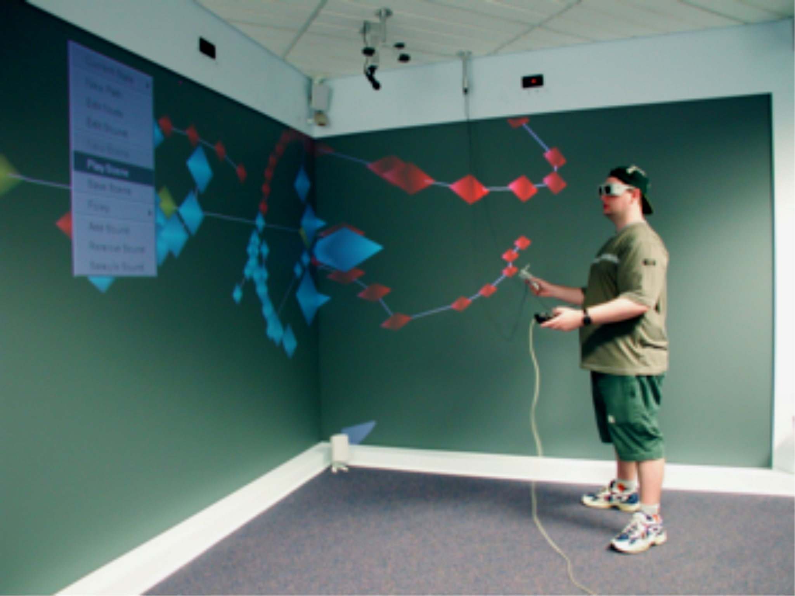
Figure 1: Soundscape sculpturing in the Wedge theatre.

Figure 2: Screen shot of the soundscape GUI application.

Example of Hardware development: Domino, a one-handed keypad controller
We have found that navigation and selection in the Wedge has been usefully facilitated using a custom-made, one-handed keypad controller developed by Hugh Fisher. Nicknamed the “Domino”, it gives a user nine different keys and can be operated using only one hand (see Figure 4).
The idea for the Domino came while developing a demonstration application for displaying and navigating through a 3D digitised landscape. The application was intended for public use by people who had not previously seen the system, and needed to be simple and easy to learn. A first design used a Polhemus 6DOF tracked stylus as a pointing device, or “air joystick”, with the user pointing or tilting in the direction they wanted to travel. Trials quickly showed that it took some time to become accustomed to the stylus, with initial movements either being extremely hesitant and not detected by the application, or too excessive, causing uncontrolled direction changes and jumps.
The Domino was built using the internals of a peripheral known as the Claw [10], which is a small keypad that can be daisy chained to a standard PC keyboard. The player rests one hand (usually the left) on the Claw and is able to issue any of nine programmable keystrokes. The other hand is free to operate the mouse. This style of interaction is widely used by players of real time action PC games, who have rediscovered the efficiency of the original mouse and chord keyboard human computer interface designed by Douglas Engelbart [11].
The Claw is designed for desktop use, being molded in the shape of a hand rest with a flat base. With a bit of cutting, it was possible to extract the switches and controlling logic and to build them into a small plastic box, extending the cable length while doing so. As the picture shows, the result is about the size of a fat TV remote controller, comfortably held in one hand with the buttons operated by the thumb. The combination of black switches and black plastic box is not a good one for dimly lit VR centres, so the switches were highlighted with adhesive white dots bought from the local newsagent. (Which also inspired the name.)
One advantage of using the Claw over other similar devices is that absolutely no software need be installed to use it! To the host computer it appears to be a standard computer keyboard, and the choice of keystroke bindings to switches is handled entirely by programming within the device itself. By basing our controller on this hardware, we have a device that works on any computer with a PS/2 keyboard, running any operating system, and which can be plugged in without any concern for drivers, reboots, or any need for administrative privileges.
Tests have shown that the untracked Domino, in combination with a magic carpet navigation metaphor, has allowed an easy navigation of 3D scenes for first-time users.
For Java3D environments, a keyboard extender has the additional advantage that it can be used to interact with a Swing thread of the application. Because the 6DOF mouse and head-tracker have been programmed to interact with Java’s Canvas3D component upon which the scene graph is displayed, interaction with Swing menus is effectively blocked without access to another device. Using the Domino, we were able to construct heavyweight pop-up menus. In the future, we are keen to experiment with Wedge applications that use two daisy-chained Dominos to enable multiple user interaction.

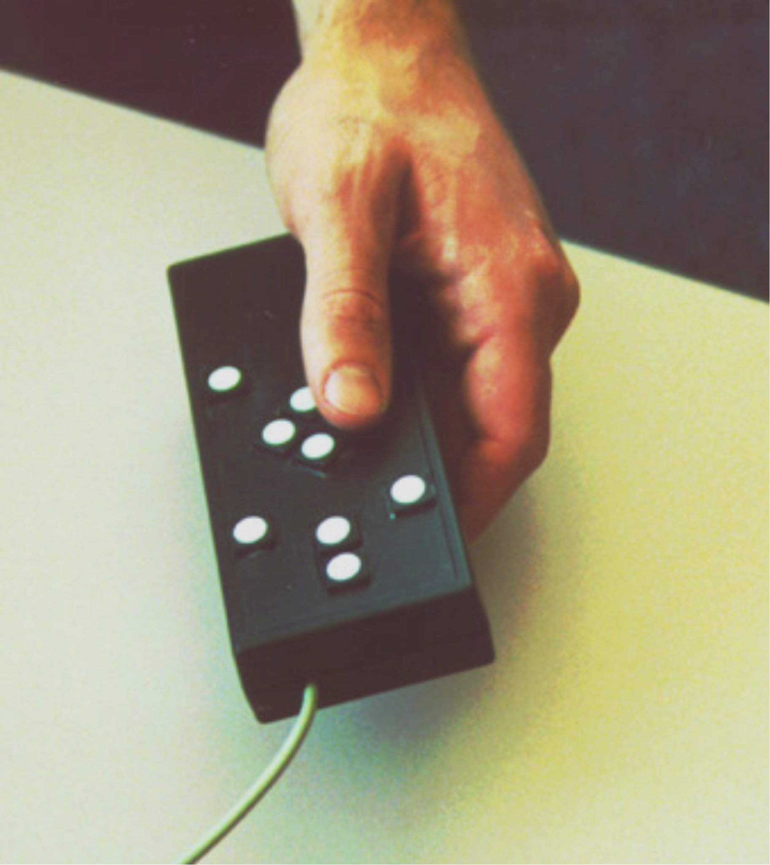
Figure 4: The Domino keyboard extender.

Example of Course assignment: FSN in Java
In Jurassic Park One, the little heroine used a 3D graphical interface to UNIX to command the closing of a door. Students of the eScience computer graphics course were asked as an assignment to create the same interface in Java (without the dinosaurs!). Silicon Graphics (SGI) made the original application some years ago (before 1992 indeed). The program was called FSN: “FSN (pronounced fusion) is a File System Navigator in cyberspace. It lays out the directories in a hierarchy with each directory represented by a pedestal. The height of the pedestal is proportional to the size of the files in the directory.”[13].
This simple assignment involved integrated 2D and 3D interfaces, creation of a 3D scene, use of recursion, introduction to data visualisation (tree and hierarchical data [14]), and navigation metaphors.
Some of our best students eventually transformed this task into a Virtual Reality experience just by using our Tiwi interface to the Wedge.

Figure 3: Screen shot of GUI version of the assignment

Example of networked application Tiwi-TV
Tiwi-TV is a demo application that shows off the audio and video streaming tools built in the escience.collab packages. It creates a sort of virtual lounge room scene with a television in the foreground. The television displays streamed video transmitted by another RTP video streaming application: typically a JMFStudio. It also plays audio streamed in from remote applications and will transmit audio out for others to hear. This allows Tiwi-TV to be used for simple video-conferencing type interactions.
In its current form Tiwi-TV serves only as a basic demo of the Wedge and the Tiwi toolkit. It needs further work to turn it into a truly useful (and robust) application.

Experiences and future work
Students taking the Graduate Diploma eScience education program [7] must complete a half-semester individual project before they graduate. It has been our educational goal to accept students into the program who have not had any computing experience, and to have them able to develop 3D virtual environments on the Wedge for their projects. Because our TIWI interface is still in its developmental phase, this was only achieved by two of the five projects undertaken last semester. The Java3D API, itself, is in a stage of development and finding the solution to the many practical problems encountered in building applications was a great challenge for the students. However, we have been delighted by the outcome of this course and feel that much of the body of software developed will be able to be reused by future students. A preliminary release of TIWI can be found at [12].
The next big step for the teaching side of the group will be the setting up of the eScience Masters program. One of the main orientations of this master is based on the development of a course and projects around internetworked virtual reality. To come along this new education program, the group will be involved in the GrangeNet project [19].
GrangeNet (Grid and Next Generation Network) is an Australian Aus$14 million fund. The core participants in the GrangeNet consortium are APAC, AARNet, the CRC for Enterprise Distributed Systems Technology, Cisco and PowerTel.
GrangeNet will install, operate and develop an optical network with an initial backbone capacity of 2.5Gbps, capable of expanding to 10Gbps. The backbone will connect the AARNet Points-of-Presence (POPs) and the high-performance computing systems at APAC partner sites in Melbourne, Canberra, Sydney and Brisbane.
GrangeNet will be driven by leading applications from the Australian research community, from users of high-performance computing systems and from a range of specific communities of interest.
It will develop and deploy grid services including distributed computing, collaborative visualisation, cooperative environments and digital libraries.

Conclusion
In this paper, we describe a new group working with Virtual Reality at the Australian National University. We have chosen to use Java as a main computing language and use a VR device called the Wedge to bring excitement to our teaching. One of the main goals of the group is to connect together several Wedges and to explore the development of applications for networked configurations. One of the reasons for our presence in Laval is to encourage the development of cross projects between our team and other French groups working in the same area.

References
[1] Henry Gardner and Rod Boswell, “The Wedge Virtual Reality Theatre”, in Proceedings of the Apple University Consortium Conference, Sept. 23-26, 2001, ISBN0-947209-33-6, http://auc.uow.edu.au/conf/conf01/downloads/AUC2001_Proceedings.pdf (2001).
[2] Carolina Cruz-Neira, Daniel J. Sandin and Thomas A. De-Fanti, “Surround-Screen Projection-Based Virtual Reality: The Design and Implementation of the CAVE”, Proc. SIGGRAPH 93, Anaheim, California, USA, 1-6 August 1993, Association of Computing Machinery, New York, 1993, pp 135-142.
[3] Drew Whitehouse, “Building Screen Based Immersive Virtual Environments on a Budget - the Wedge”, ACM SIGGRAPH Computer Graphics, 33(4) (1999) 9.
[4] http://www.sgi.com/software/optimizer/
[5] http://www.sgi.com/software/performer/
[6] http://www.avango.de/
[7] http://eScience.anu.edu.au/
[8] D. Cox, R. Patterson and M. Thiebaux, Virtual Director, <http://virdir.ncsa.uiuc.edu/virdir/> (1995).
[9] Lake Techology, Audio VR Professional and Research Tools <www.lake.com> (2000).
[10] http://www.claw.com.au
[11] Engelbart, D. C. (1988). The augmented knowledge workshop, in A. Goldberg (Ed.), A history of personal workstations (pp. 185-232). New York: ACM Press.
[12] Tiwi : http://ephebe.anu.edu.au/doc/
[13] FSN : http://www.sgi.com/fun/freeware/3d_navigator.html
[14] nDimensions : http://www2.ifib.uni-karlsruhe.de/hyperd/zb/
[15] Java as a Teaching Language : http://java.oreilly.com/news/teachjava_0101.html
[16] Cay Horstmann, Gary Cornell. Core Java 2, Volume I – Fundamentals.
[17] Java 3DTM API 1.3 Specification Beta 1 http://java.sun.com/products/java-media/3D/releases.html#spec_1_3
[18] ConfiguredUniverse : http://www.j3d.org/news/siggraph2001_bof_report.html
[19] GrangeNet : http://feit.anu.edu.au/grangenet/

